  - SYSTEM ANALYSIS AND DESIGN

DriverPass
System Design Document
CS 255 Project Two
Caleb Dinsmore
CS 255: System Analysis and Design
Southern New Hampshire University
August 16, 2026

UML Use Case Diagram
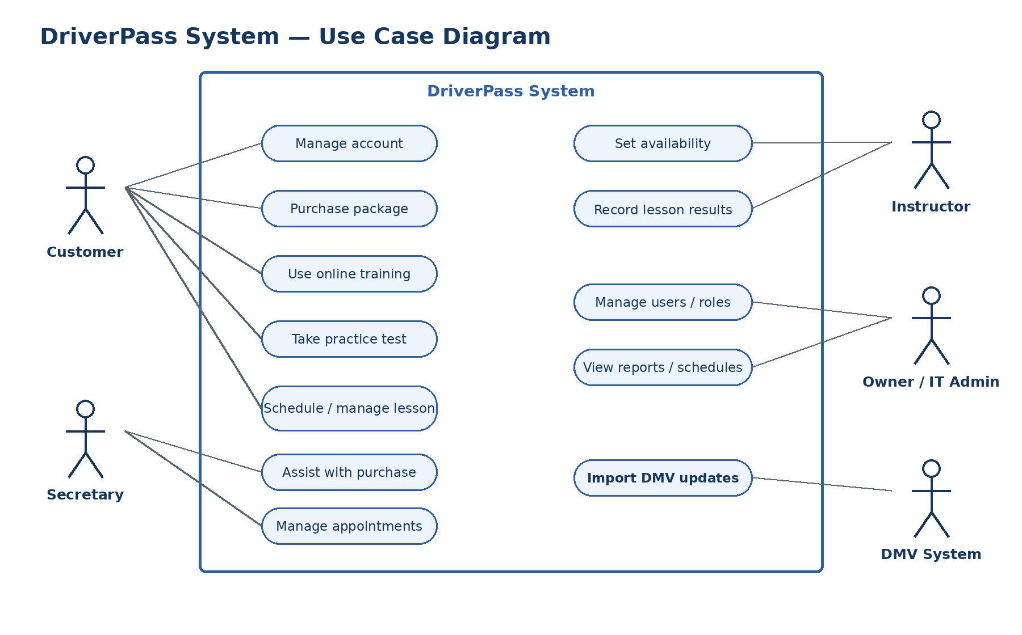
Figure 1. Major DriverPass users and the system functions available to each role.
This diagram defines the system’s scope from each user’s point of view. Customers manage their accounts, buy packages, use online training, take practice tests, and schedule lessons. The secretary helps customers with purchases and appointments. Instructors maintain availability and record lesson outcomes. The owner and IT administrator manage access, reports, and operations, while the DMV system supplies current rules and test content.

UML Activity Diagram: Schedule a Driving Lesson
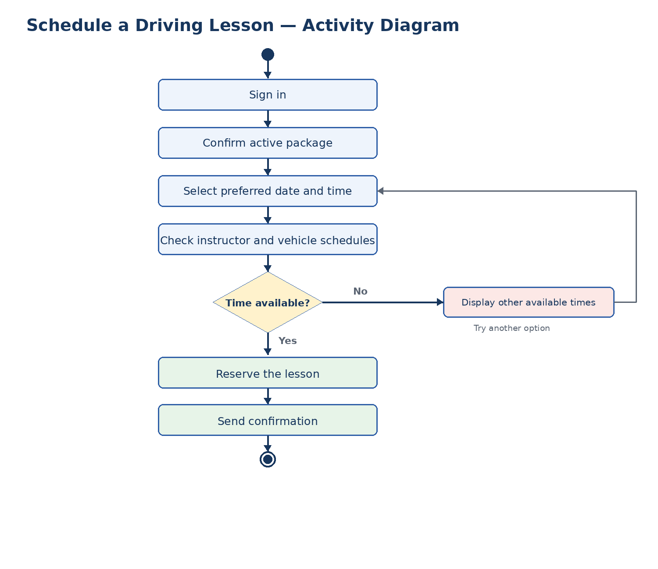
Figure 2. Workflow for scheduling a driving lesson.
The workflow validates that the customer has an active package before checking both instructor and vehicle availability. If the selected time is unavailable, the customer returns to the time-selection step. The system creates the reservation and sends a confirmation only after all required resources are available, which prevents double booking.

UML Activity Diagram: Purchase a Training Package
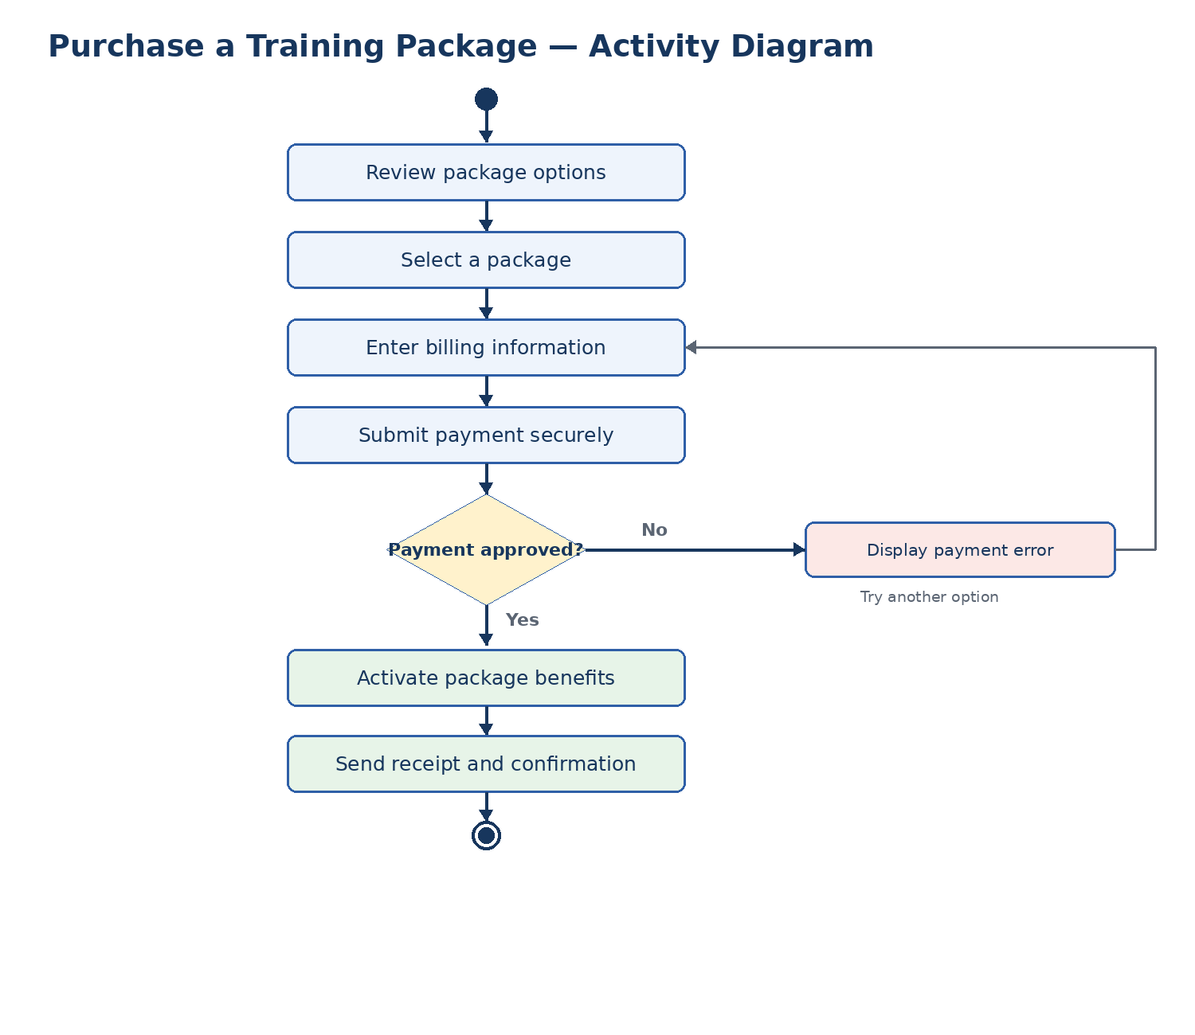
Figure 3. Workflow for purchasing a DriverPass training package.
The customer reviews a package, provides billing information, and submits payment through a trusted payment service. A rejected payment returns the customer to a safe retry path and does not activate benefits. An approved payment activates the package, records the purchase, and generates a receipt and confirmation.

UML Sequence Diagram
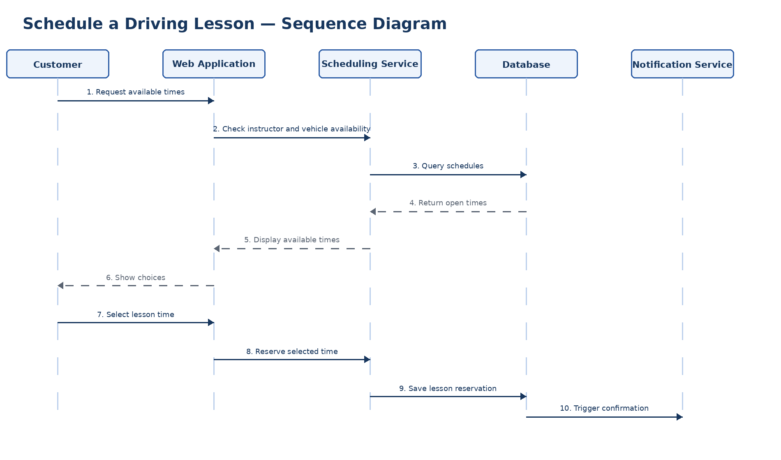
Figure 4. Order of messages exchanged while a customer schedules a lesson.
The sequence begins when the customer requests available times. The scheduling service checks stored instructor and vehicle schedules before presenting choices. After the customer selects a time, the service saves one complete reservation and triggers a confirmation. This order ensures that the system never confirms a lesson before the reservation is successfully stored.

UML Class Diagram
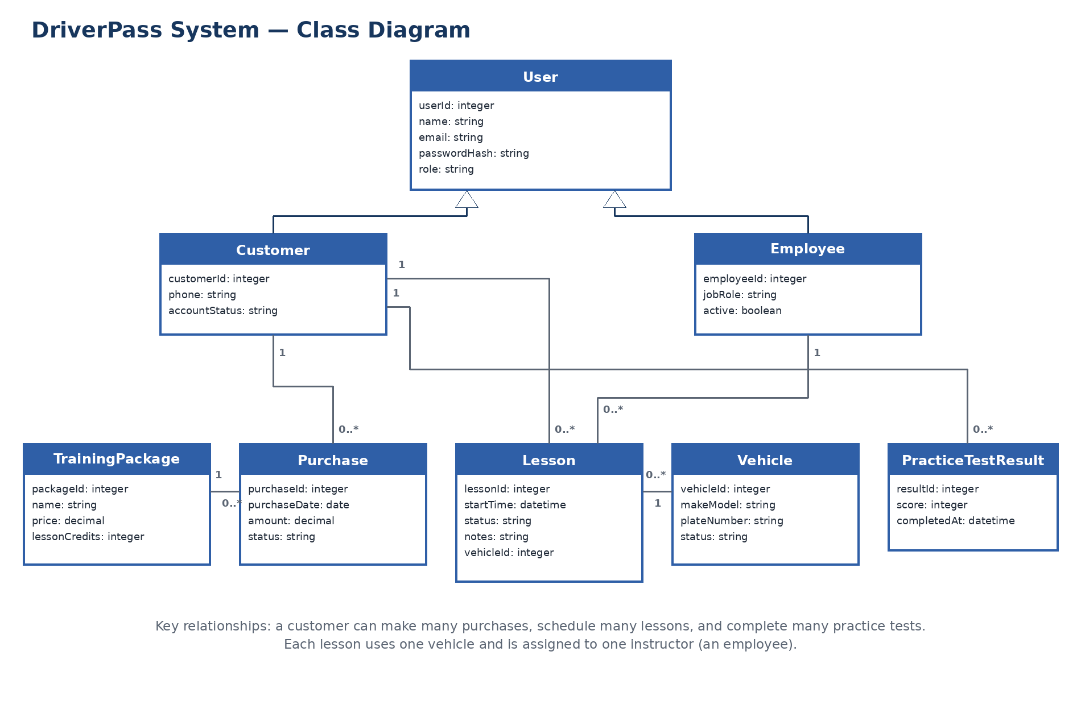
Figure 5. Core DriverPass classes, attributes, inheritance, and multiplicities.
The class model defines the information developers need to store. User contains details shared by customers and employees. Purchases connect customers to training packages. Lessons connect customers, employees, and vehicles. Practice-test results remain tied to the customer who completed them. The multiplicities show where one record may be associated with several related records.

Technical Requirements
The proposed solution is a responsive, browser-based system supported by a secure application server and relational database. This design gives customers and employees access from common devices without requiring separate desktop software.

Hardware and Devices
- Cloud-hosted application servers that can scale during busy registration periods.
- A managed database platform with redundant storage, automated backups, and point-in-time recovery.
- Office computers for the owner, secretary, and IT administrator, plus mobile-capable devices for instructors.
- Reliable business internet, a network firewall, and secure wireless access at DriverPass locations.
- Customer-owned computers, tablets, or phones with a modern browser and internet connection.

Software and Services
- A responsive web application supporting current versions of Chrome, Edge, Firefox, and Safari.
- A server-side application for authentication, packages, payments, training, tests, scheduling, and reporting.
- A relational database such as PostgreSQL or MySQL for users, roles, purchases, lessons, vehicles, content, and results.
- A trusted payment provider so DriverPass does not store full payment-card information.
- Email or text-message services for confirmations, cancellations, reminders, and receipts.
- A scheduled integration that retrieves DMV updates and records the date and version of imported content.

Development and Testing Tools
- A shared source-control repository with separate development, test, and production branches.
- An integrated development environment, automated build pipeline, and issue tracker.
- Automated unit, integration, security, and browser-compatibility testing before deployment.
- A staging environment that mirrors production so releases and DMV updates can be verified safely.
- Centralized monitoring and logging for failures, slow responses, and unusual account activity.

Technical Requirements (Continued)

Infrastructure and Operations
- HTTPS encryption for browser, payment, and external-service connections.
- Role-based access so each user sees only the functions required for that role.
- Secure password hashing, rate limiting or account lockout, inactivity time-outs, and protected password resets.
- Daily automated backups, periodic recovery tests, and a documented recovery plan.
- Redundant hosting, health monitoring, and audit records for account, schedule, payment, content, and administrative changes.
- A validated DMV synchronization process with a fallback to the most recent approved content when the external service is unavailable.

Performance and Capacity Targets
- Normal pages should load within approximately three seconds under expected traffic.
- Lesson scheduling must reserve the instructor and vehicle in one database transaction to prevent double booking.
- The customer portal should be available 24 hours a day, with planned maintenance announced in advance.
- Hosting capacity and availability should be monitored and expanded as DriverPass adds customers, instructors, vehicles, or locations.

Security and Privacy Controls
- Collect only information required to operate the service and limit employee access to customer records.
- Keep payment-card handling within the approved payment provider whenever possible.
- Record security-relevant events and review logs for repeated sign-in failures or unusual administrative activity.
- Apply software and operating-system updates promptly after testing in the staging environment.

